**Phylogenetic analysis of the threshold model**

In this tutorial, we're going to cover two different analyses:

1. We're going to estimate the correlation between two binary characters, as well as between a binary & a continuous character, assuming a threshold model of character evolution for our discrete character; and   
2. We're going to reconstruct the ancestral states of a multistate, naturally ordered character on the tree assuming the threshold model.

If you want to follow along without actually running the simulation and the MCMC, you can download the following R data object: [threshold.Rdata](http://www.phytools.org/eqg/Exercise_6.2/data/threshold.Rdata).

**Correlation between discrete & continuous characters under the threshold model**

Here, we're going to use Bayesian MCMC to sample the evolutionary parameters of our model from their joint posterior probability distribution. These parameters include evolutionary rates (σ2s) for each continuous character; and the correlation between our discrete and continuous character. Since this is a binary model with a single threshold - we don't have to worry about the relative positions of the thresholds.

We'll start by simulating a tree & two correlated Brownian variables on the tree.

For illustrative purposes, let's start by using threshBayes on two continuous characters & show that the result lines up closely with our MLE of the correlation.

## first, load phytools

**library**(phytools)

tree <- **pbtree**(n = 100, scale = 1)

r <- 0.75 # simulate using a high correlation

V <- **matrix**(**c**(1, r, r, 1), 2, 2)

X <- **sim.corrs**(tree, V)

## set some parameters **for** the MCMC

sample <- 1000

ngen <- 5e+05

burnin <- 0.2 * ngen

## we can start by running our Bayesian MCMC on the original data

AA <- **threshBayes**(tree, X, types = **c**("cont", "cont"), ngen = ngen, control = **list**(sample = sample))

## [1] "gen 1000"

## [1] "gen 2000"

## [1] ...

## [1] "gen 500000"

## we can compute our MLE of the correlation

V.mle <- **phyl.vcv**(X, **vcv**(tree), lambda = 1)$R

V.mle[1, 2]/**sqrt**(V.mle[1, 1] * V.mle[2, 2])

## [1] 0.761

## here is our 'post burnin' mean from the posterior sample

**mean**(AA$par[(burnin/sample + 1):**nrow**(AA$par), "r"])

## [1] 0.755

## plot our likelihood profile

**plot**(AA$par[, "logL"], type = "l", xlab = "generation", ylab = "logL")

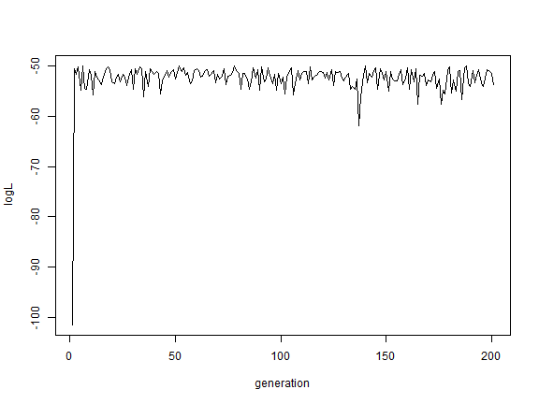

## plot our posterior sample **for** the correlation

**hist**(AA$par[(burnin/sample + 1):**nrow**(AA$par), "r"], xlab = "r", ylab = "frequency",

main = **NULL**)

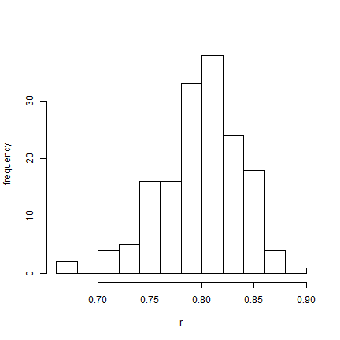

OK, this was just a proof-of-concept exercise. Now let's try the same thing after having converted one of our trait values into a threshold character.

## convert X[,2] to a binary character

X[, 2] <- **as.numeric**(**sapply**(X[, 2], threshState, thresholds = **setNames**(**c**(0,

**Inf**), 0:1)))

BB <- **threshBayes**(tree, X, types = **c**("cont", "disc"), ngen = ngen, control = **list**(sample = sample))

## [1] "gen 1000"

## [1] "gen 2000"

## [1] ...

## [1] "gen 500000"

## what is our estimate of the correlation?

**mean**(BB$par[(burnin/sample + 1):**nrow**(BB$par), "r"])

## [1] 0.5804

## plot our likelihood profile

**plot**(BB$par[, "logL"], type = "l", xlab = "generation", ylab = "logL")

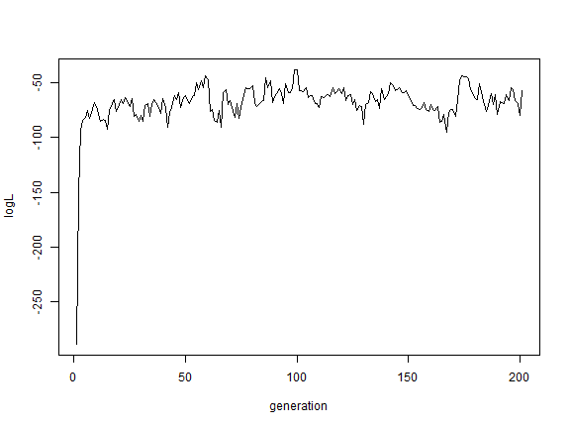

## plot our posterior sample **for** the correlation

**hist**(BB$par[(burnin/sample + 1):**nrow**(BB$par), "r"], xlab = "r", ylab = "frequency",

main = **NULL**)

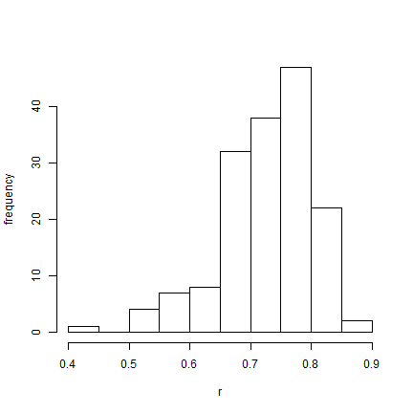

Finally, let's analyze two binary characters under the same model. Remember, each time we're losing information about the underlying correlation between liabilities. Nonetheless....

## convert X[,2] to a binary character

X[, 1] <- **as.numeric**(**sapply**(X[, 1], threshState, thresholds = **setNames**(**c**(0,

**Inf**), 0:1)))

CC <- **threshBayes**(tree, X, types = **c**("disc", "disc"), ngen = ngen, control = **list**(sample = sample))

## [1] "gen 1000"

## [1] "gen 2000"

## [1] ...

## [1] "gen 500000"

## what is our estimate of the correlation?

**mean**(CC$par[(burnin/sample + 1):**nrow**(CC$par), "r"])

## [1] 0.5456

## plot our likelihood profile

**plot**(CC$par[, "logL"], type = "l", xlab = "generation", ylab = "logL")

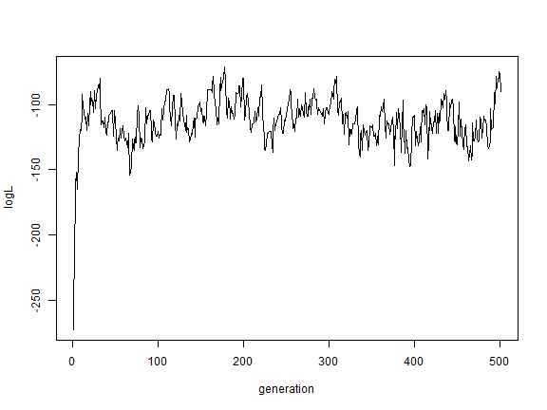

## plot our posterior sample **for** the correlation

**hist**(CC$par[(burnin/sample + 1):**nrow**(CC$par), "r"], xlab = "r", ylab = "frequency",

main = **NULL**)

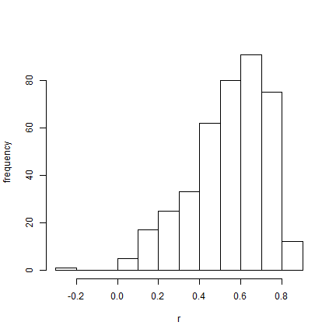

So we can see that we can see that threshBayes does a reasonable job at estimating the correlation between binary & continuous characters under the threshold model.

## let's use coda to compute effective sample sizes & HPDs

**require**(coda)

*## Loading required package: coda*

## first, analysis A

rA <- AA$par[(burnin/sample + 1):**nrow**(AA$par), "r"]

**class**(rA) <- "mcmc"

**effectiveSize**(rA)

## var1

## 401

**HPDinterval**(rA)

## lower upper

## var1 0.663 0.8319

## attr(,"Probability")

## [1] 0.9501

## second, analysis B

rB <- BB$par[(burnin/sample + 1):**nrow**(BB$par), "r"]

**class**(rB) <- "mcmc"

**effectiveSize**(rB)

## var1

## 35.78

**HPDinterval**(rB)

## lower upper

## var1 0.3522 0.8179

## attr(,"Probability")

## [1] 0.9501

## finally, analysis C

rC <- CC$par[(burnin/sample + 1):**nrow**(CC$par), "r"]

**class**(rC) <- "mcmc"

**effectiveSize**(rC)

## var1

## 37.51

**HPDinterval**(rC)

## lower upper

## var1 0.1622 0.8076

## attr(,"Probability")

## [1] 0.9501

**Ancestral character estimation under the threshold model**

We can also do ancestral character reconstruction for discrete characters using the threshold model.

## simulate tree & data

n <- 100

ngen <- 1e+06

sample <- 1000

tree <- **pbtree**(n = n, scale = 10)

x <- **fastBM**(tree, sig2 = 1, a = 0.5, internal = **TRUE**)

th <- **sapply**(x, threshState, thresholds = **setNames**(**c**(0, 0.5, 2, **Inf**), **letters**[1:4]))

mcmc <- **ancThresh**(tree, th[1:n], ngen = ngen, sequence = **letters**[1:4], control = **list**(sample = sample,

plot = **FALSE**))

*## MCMC starting....*

*## gen 1000*

*...*

*## gen 999000*

*## gen 1000000*

**plotTree**(tree, setEnv = **TRUE**, ftype = "off")

## setEnv=TRUE is experimental. please be patient with bugs

**tiplabels**(pie = **to.matrix**(th[1:n], **letters**[1:4]), piecol = **palette**()[1:4], cex = 0.3)

**nodelabels**(pie = mcmc$ace, piecol = **palette**()[1:4], cex = 0.8)

**nodelabels**(pie = **to.matrix**(th[1:tree$Nnode + n], **letters**[1:4]), piecol = **palette**()[1:4],

cex = 0.4)

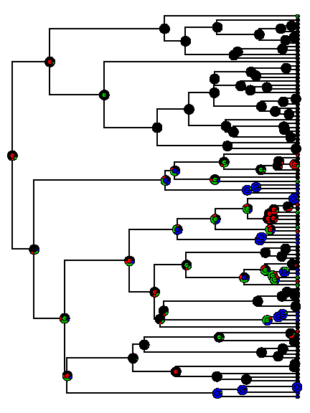

Theoretically, we can even use this method to identify the relative positions of thresholds:

**colMeans**(mcmc$par[(0.2 * ngen/sample):(ngen/sample) + 1, **letters**[1:4]])

## a b c d

## 0.0000 0.3878 1.2953 Inf

**par**(mfrow = **c**(2, 1))

**par**(mar = **c**(4.1, 5.1, 2.1, 2.1))

xx <- **hist**(mcmc$par[(0.2 * ngen/sample):(ngen/sample) + 1, **letters**[2]], plot = **FALSE**)

**plot**(xx$mids, xx$density, type = "l", xlab = "threshold a->b", ylab = "density")

**lines**(**c**(0.5, 0.5), **c**(0, 1.1 * **max**(xx$density)), lty = "dashed")

xx <- **hist**(mcmc$par[(0.2 * ngen/sample):(ngen/sample) + 1, **letters**[3]], plot = **FALSE**)

**plot**(xx$mids, xx$density, type = "l", xlab = "threshold b->c", ylab = "density")

**lines**(**c**(2, 2), **c**(0, 1.1 * **max**(xx$density)), lty = "dashed")

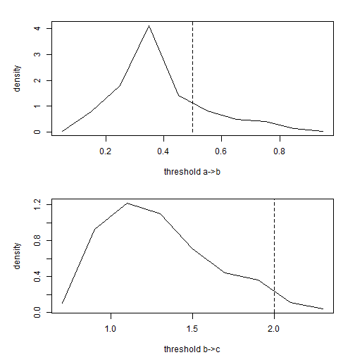

That's it!

*Written by Liam J. Revell. Last updated Aug. 10, 2013*